serengeti*motion
contribution for the living box competition

[ architecture+design by htarchitektur; germany ]

the house leaves the place, becomes mobile, moves all over the world to make landscape explorable from out of the kitchen window.
individual vacation becomes more comfortable . nature gets closer, pushes inside, fills the air and the lungs.
today this individual living unit is brought to the serengeti. a unique safari of extremely dense impressions awaits the traveller. the hiding places of gnu herds, lions and zebras are found unveiled.
>> discover slowness.
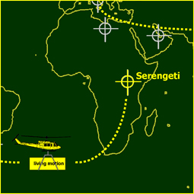
[franchise vacation concept]

[site]*motion is a concept of mobile vacation homes spread all over the world. the living unit is being sent to different sites in one container by airfreight, road or shipping. partners of [site]*motion in each country provide, comparing to a franchise concept, homebases, to dock on the individual living units.
these homebases, one for each unit can be connected to the living unit and move it.

the quality of the homebase depends on the landscape to be visited. tires and floats, even caterpillar propulsions are possible to be used as a drive.
the serengeti*motion homebase offers a base station with caterpillar homebases. with the speed of the animals, who never stay too long in one place, the living unit can follow the herds of gnus, zebras and lions.
being as well quiet as continous beside the animals the travellers gain the confidence of them. better views and deeper understanding of the landscape are the result of a 24 hour safari in closest distance to the wildest beasts.

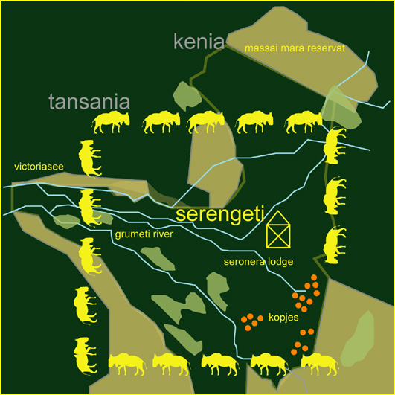
[serengeti- “the great migration”]

the 30,000 square kilometers of the savannah-plateau are characterized by wide plains of grass, some stone clusters - the “kopjes” - which are shared by resting lions and the woods at grumeti river.
the animals in the serengeti live a life of journeys. the dry period over the most of the year is followed by the rainy season in winter and spring time. the climate and the search for food make the animals year by year move southwards in the grumeti area early in spring and back to the north in autumn.

this “great migration” with its constant movement of herds of gnus, topis, zebras but also elephants and lions invites to follow the track to discover by safari the beauty of this specific region.

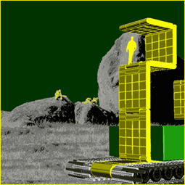

[serengeti*motion]

to discover the beauty of the serengeti reservation the tourist has to take part in the “great migration”.
the hombase of serengeti*motion enabels the individuals living units to move.
this moveabele platform is able to follow the track of the animals - 0,75 kilometers per hour, about 10 kilometers per day - the living unit can follow the herds and guarantee a full view the whole time.

still the comfort and flexibility of a nairobi hotel room is around. independent of day and night, gasoline and breakfast buffet, long-term observations and a deeper understanding of landscape are possible. explore the world in slow motion

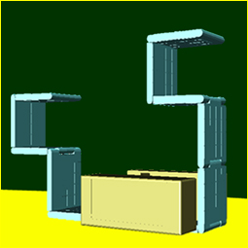
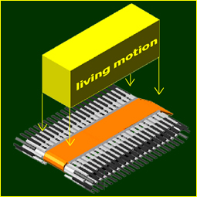
[base station]
base stations are spread all over the world especially near precious landscape regions and wildlife areas.
like a rent-a-bike station the homebases are collected at one point and connected to the arriving individual living units of the traveller.

from this point the journey starts into the serengeti. supplied for the trip and guided by a gps-signal the travellers themselves are responsible for their journey.

at several points in the serengeti they can reload their watertanks and get electric power. the possibility of guides and group safaris are features the local franchise partners offer.

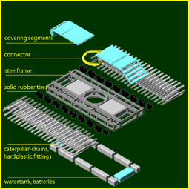

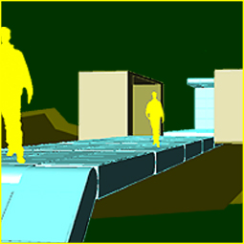

[homebase]
the homebase is the propulsion unit. its construction depends on the local infrastructure. the serengeti homebase is a caterpillar drive with a steelframe for static needs and chain drives for moving through savannah lands without destroying it by too much ground pressure. the maximum speed of 0,75 kilometers per hour and additional hardplastic fittings allows people to move on the chains safely. other parts of the steelframe are covered with metal sheets which enable walking on them.
for all kind of homebases the connector in the centre of the vehicle frame is standardized. this connector consists of a metal ring which provides sockets for electrical connections, water and waste water supply. furthermore a gps-receiver inside indicates the position of the vehicle. located around the steelframe are power units for the electric motor and watertanks for the daily needs.

[living unit]
consisting of two parts - the shells and the segmented extension arms - the whole living unit can be containerized within minutes.
the shells contain rooms for the basic needs. a kitchen, a bathroom and space for a closet and a bed appear when the shells are driven apart. but living itself finds its major quailities outside this box.
the folding extensions create space just the way it is needed. this way rooms can always respond to the landscape around them. a lot of varieties allow living in rooms with changing features. separated by clipable textile coatings, every area can become a small room for someone cocooning. the cloth also serves as protection from sun and weather, it keeps the light in
and the mosquitos out.

[living*motion]
the extension arms create a special room with every turn of a segment. space is being transformed everywhere to the space needed. the living unit assimilates the landscape around.
if there is a cave too high to climb, the segments fold up to it and let the visitor climb in. if a river needs to be crossed or the edge of a cliff stops the common people from staring down, the extension arms become the path and stretch over 12 meters to both sides.
in the desert they create shadow where it is useful and can push the living unit into the height as for protection of snakes and scorpions.

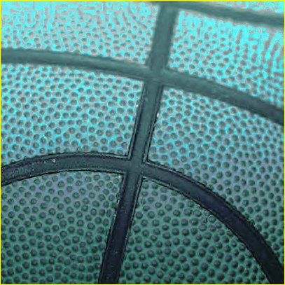

[detail]
the segmented extensions consist of a light steel frame structure, which combines static advantages and inside room for storage use. the steel panels are covered with a filigran rubber skin, which has qualities that match all the possible functions one segment can provide. be it a floor it is resistant to walk on it properly, as a wall or ceiling the surface is comfortable and tactile.
it hides dampers at several parts of the segment, where technical installations, power and light as well as furniture can be flapped out.
every element is controllable for itself and additionally from inside the shells. furniture available can be cupboards, desks, chairs and even beds.
[2005/12/03 htarchitektur]

